Lot Scheduler

User Manual

Environment Setup

**Requirements**

1. **Java Runtime Environment (JRE)**
2. **Apache Tomcat 8.5.4 (Server)**
3. **MySQL Server 5.6 + MySQL Workbench GUI + JDBC Connector (DB)**
4. **Initialize MySQL tables**
5. **Deploy Project WAR File (Compiled Source)**
6. **Start the Tomcat Service**

**Installation**

1. **Java SE Runtime Environment**
2. **Download and Install JRE**

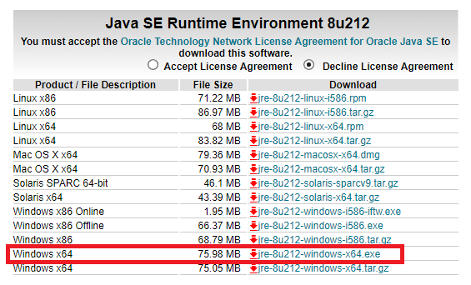[**https://www.oracle.com/technetwork/java/javase/downloads/jre8-downloads-2133155.html**](https://www.oracle.com/technetwork/java/javase/downloads/jre8-downloads-2133155.html)

1. **Apache Tomcat**
2. 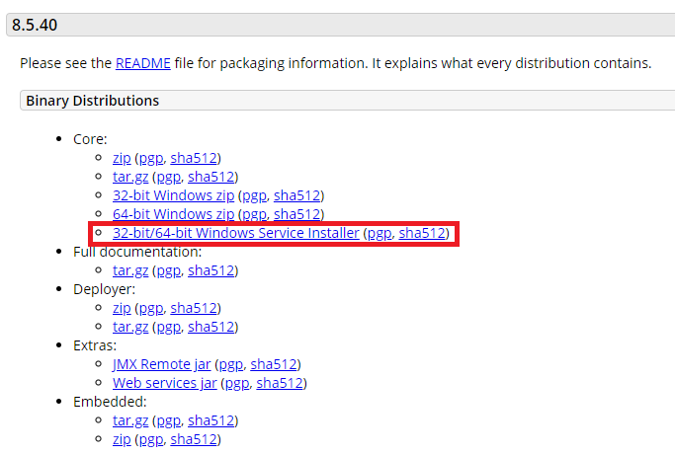**Download Apache Tomcat 8.5.4** [**https://tomcat.apache.org/download-80.cgi**](https://tomcat.apache.org/download-80.cgi)
3. **Run the Installation**

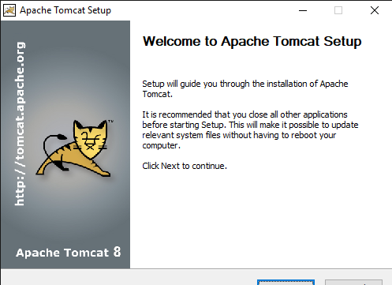

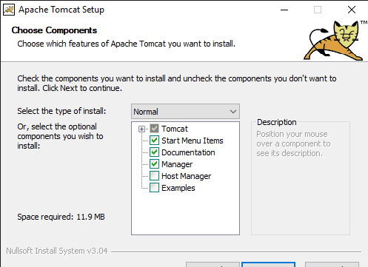

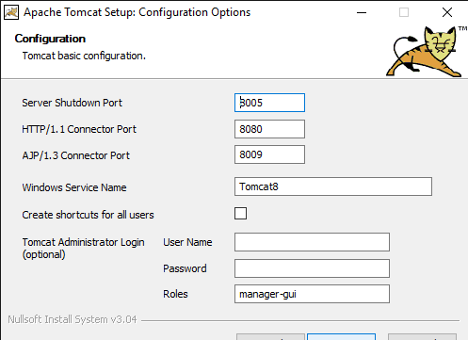

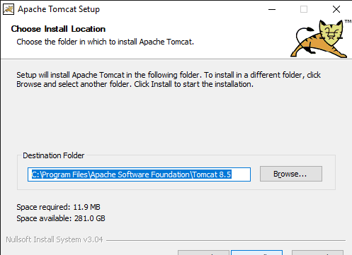

1. **MySQL 5.6**
2. **Download MySQL 5.6**

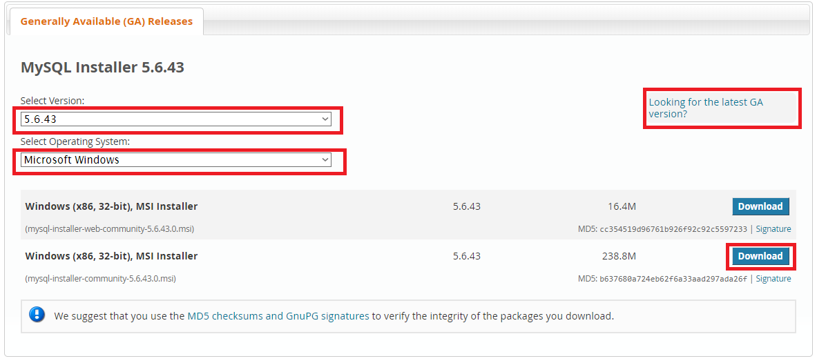[**https://dev.mysql.com/downloads/windows/installer/8.0.html**](https://dev.mysql.com/downloads/windows/installer/8.0.html)

1. 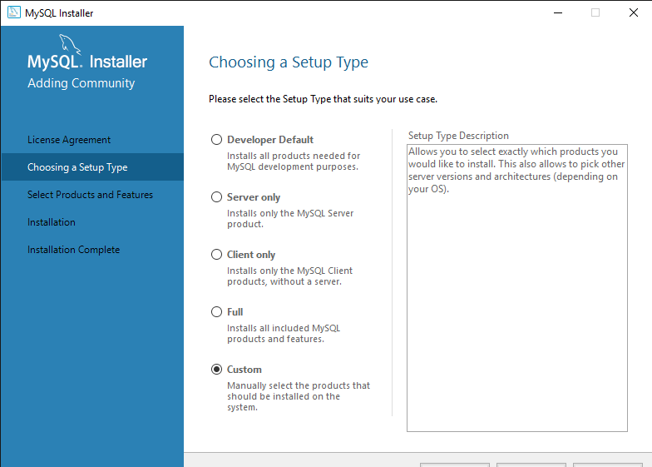**Run the Installation**

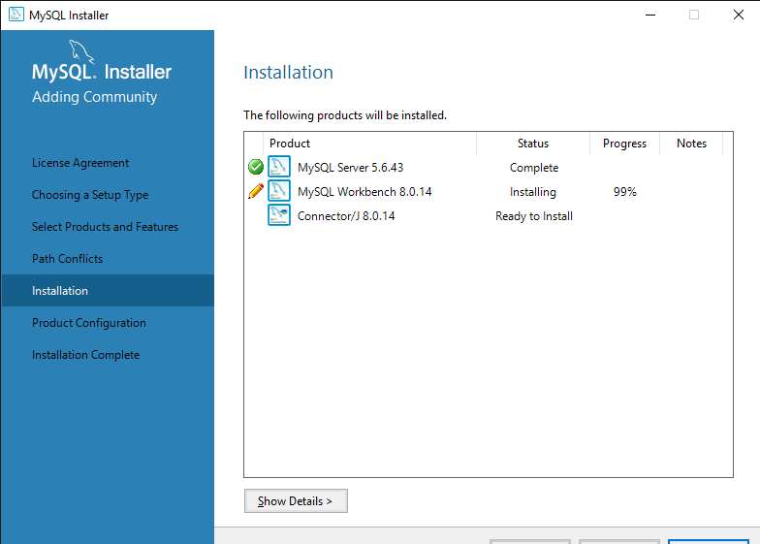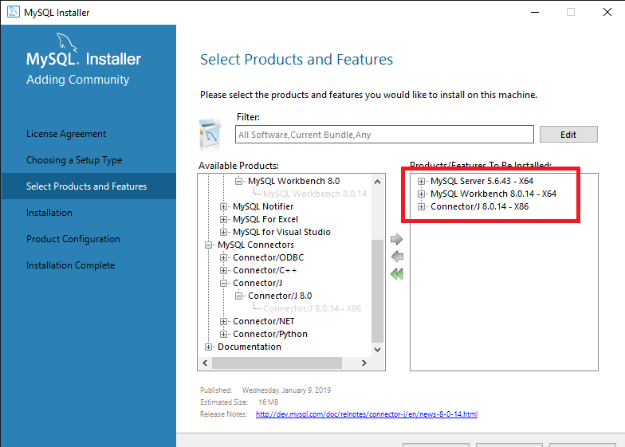

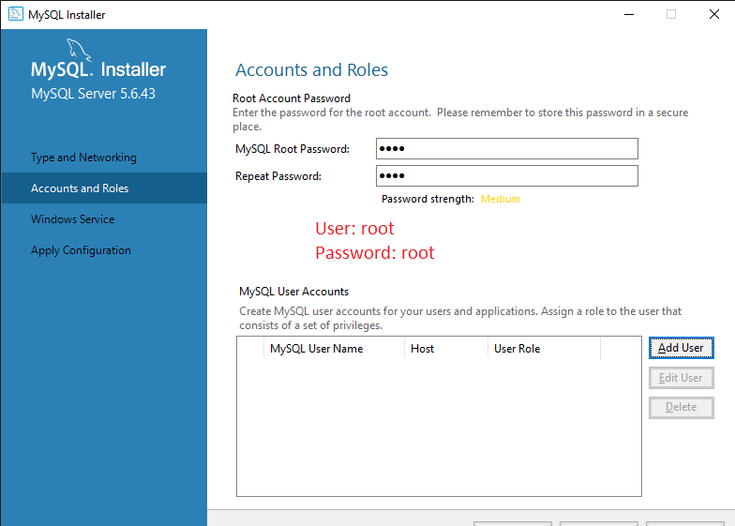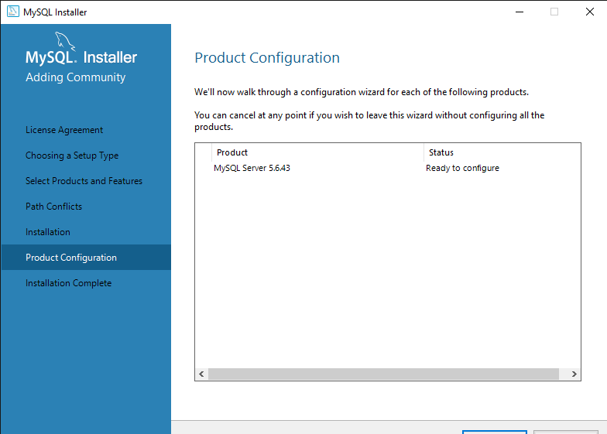

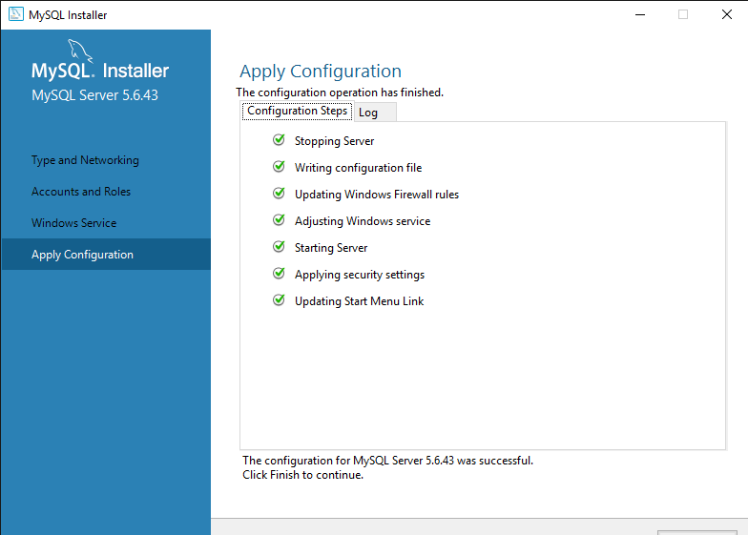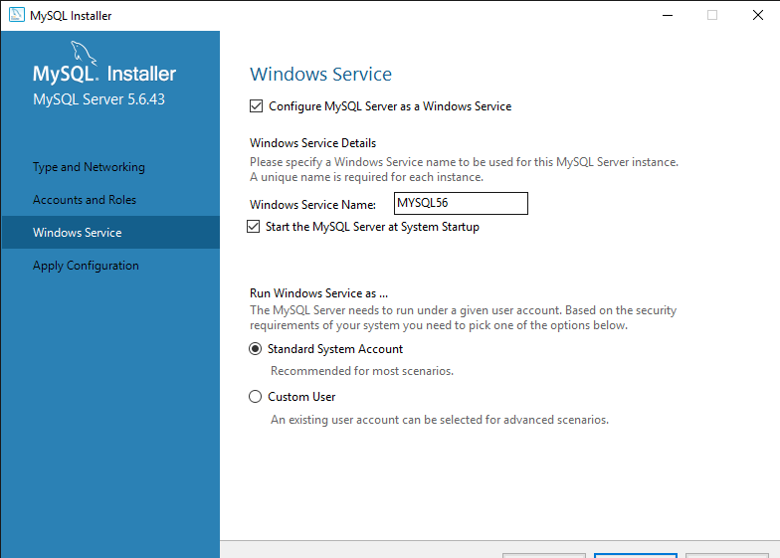

1. **Initialize the DB Tables**
2. 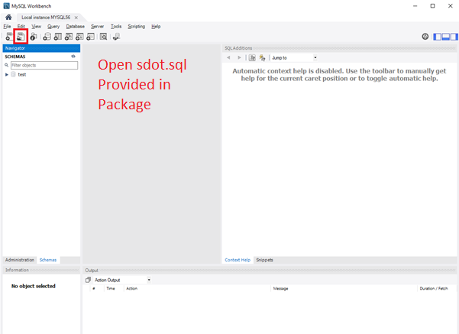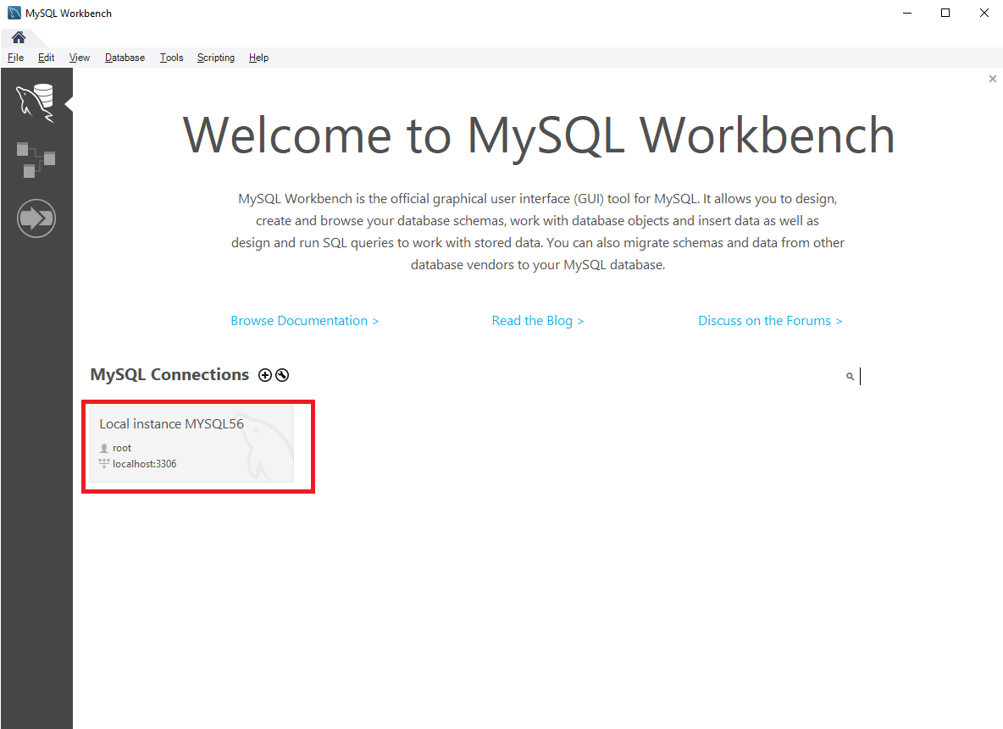**Open MySQL Workbench and SQL script**
3. 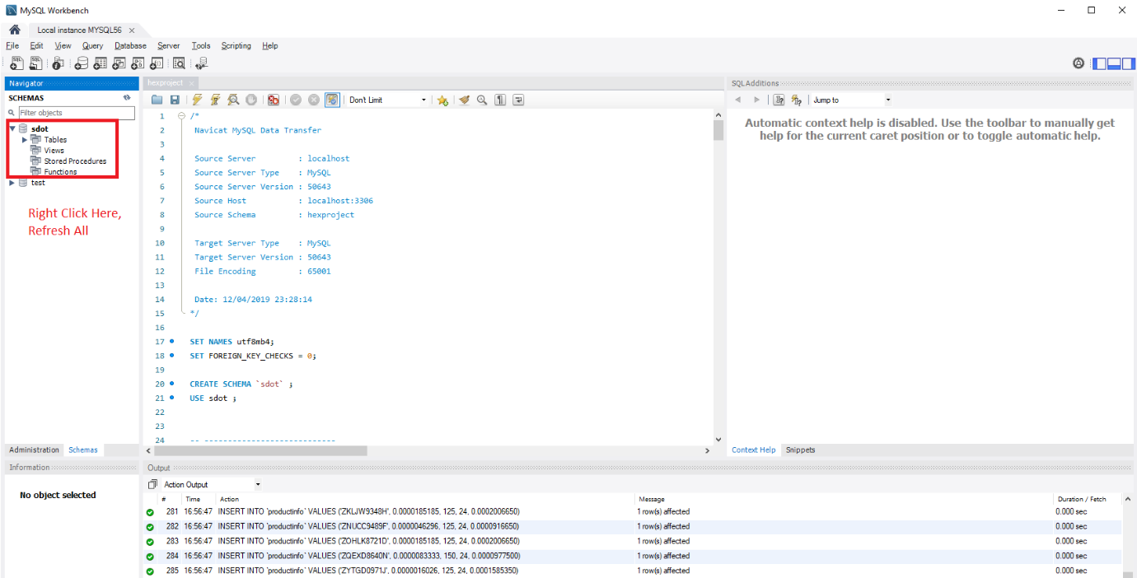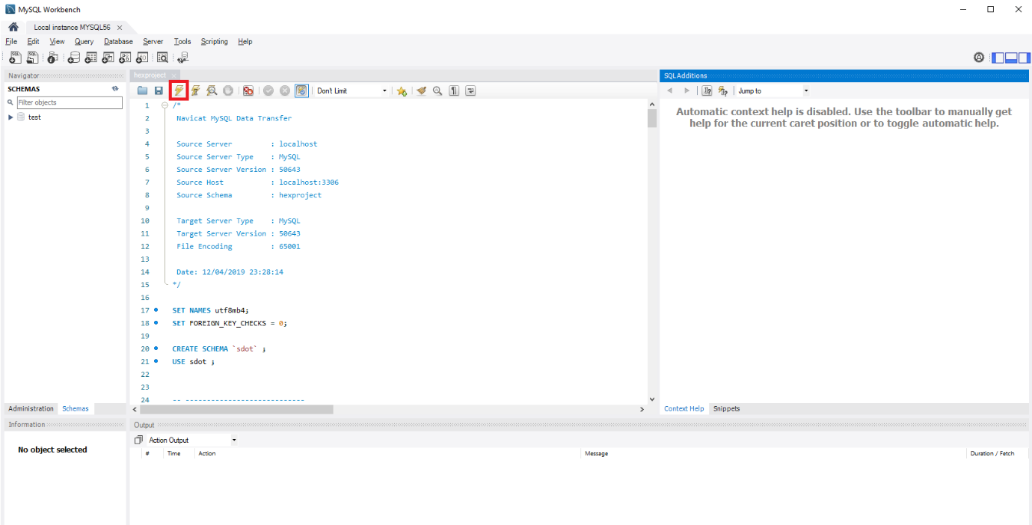**Execute the Script**
4. **Deploy the Project Package WAR**
5. **Copy Sdot.WAR into C:\Program Files\Apache Software Foundation\Tomcat 8.5\webapps**
6. **Start the Service**
7. 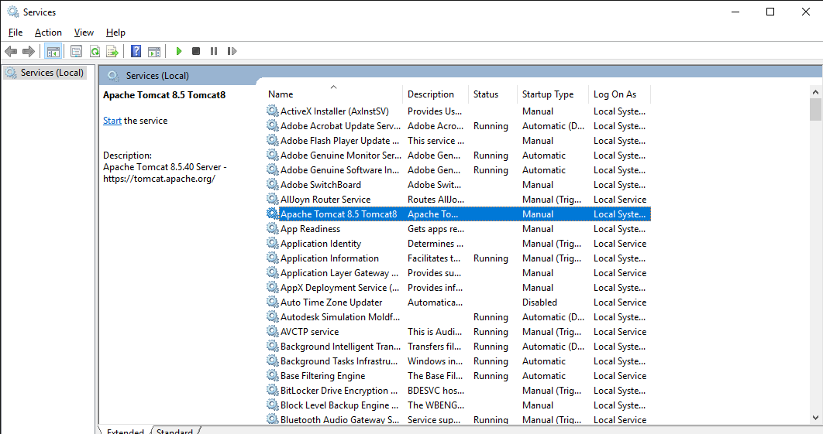**Press Windows + R, Run Services.msc, start the tomcat service**

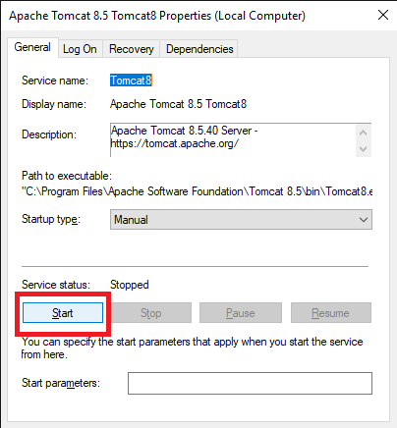

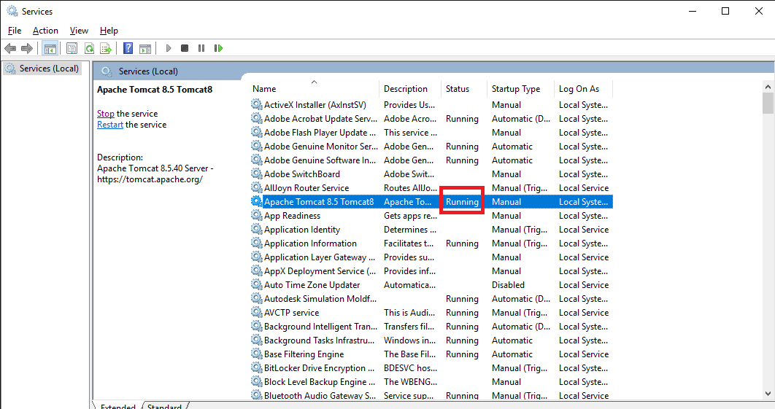

1. 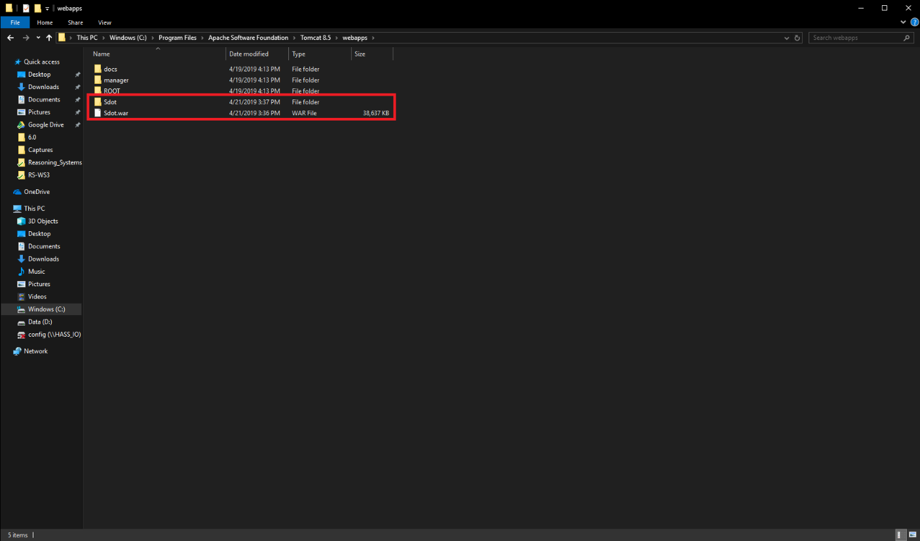**Check if Sdot_war Folder is created in C:\Program Files\Apache Software Foundation\Tomcat 8.5\webapps**
2. **Wait for about 5 minutes, than go to this link:**

[**http://localhost:8080/Sdot/lot/choosePlan**](http://localhost:8080/Sdot/lot/choosePlan)

Test Cases

**<Insert Test Cases Here>**